Customer shopping behavior
Analysis Report
Sanadi Liyanage
Business & Data Analyst
1. Project Overview
End-to-end Business Intelligence project analyzing 3,900 customer transactions to uncover purchasing patterns, customer segments, product preferences, and subscription behavior. The analysis evaluates key factors such as spending patterns, discounts, customer ratings, seasonal trends, and payment preferences to identify actionable insights and support data-driven marketing, product, customer engagement, and strategic business decisions.

2. Dataset Summary
-Rows: 3,900
-Columns: 19
- Key Features: - Customer demographics (Age, Gender, Location, Subscription Status)
- Purchase details (Item Purchased, Category, Purchase Amount, Season, Size, Color)
- Shopping behavior (Discount Applied, Promo Code Used, Previous Purchases, Frequency of Purchases, Review Rating, Shipping Type)

3. Exploratory Data Analysis using Python
Data Loading
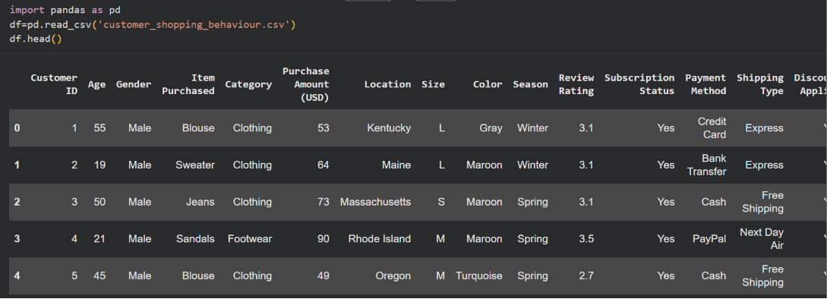

Initial Exploration
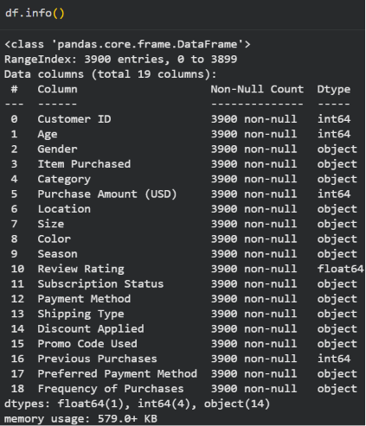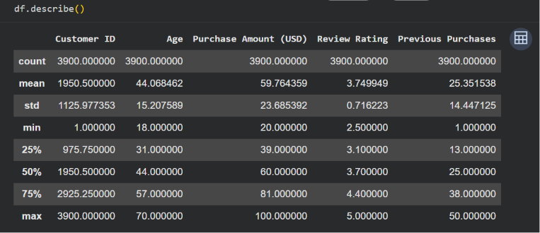

Checking for misssing data
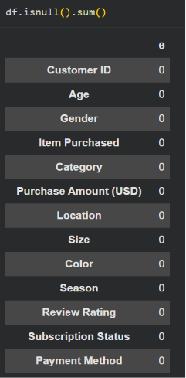

Column Standardization:
- Renamed columns to ‘snake case’ for better readability and documentation.

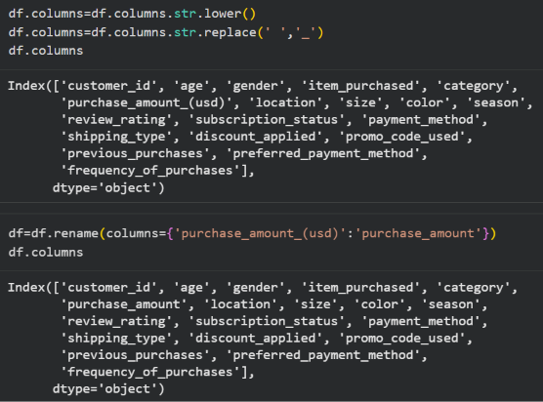

Feature Engineering:
- Created ‘age_group’ column by mapping customer ages.
- Created ‘purchase_frequency_days’ column from purchase data.

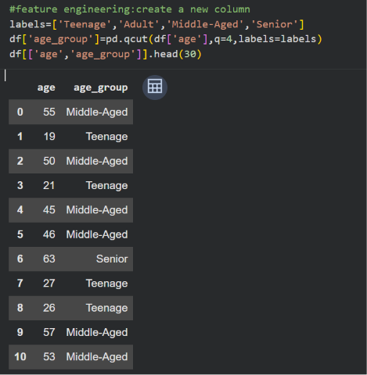
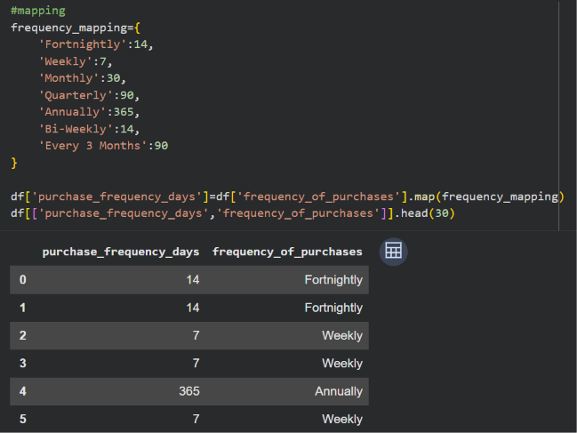

Data Consistency Check:
- Verified if ‘discount_applied’ and ‘promo_code_used’ were redundant, dropped ‘promo_code_used’.
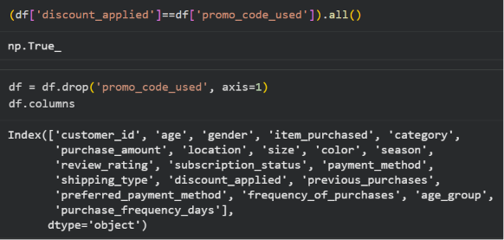

4. Data Analysis using SQL Queries
Total Revenue
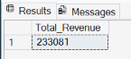

Average purchase amount
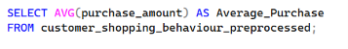
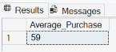

Minimum purchase amount
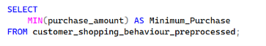
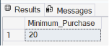

Maximum purchase amount
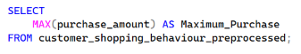
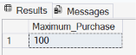

Total purchases by age groups
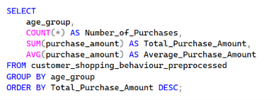
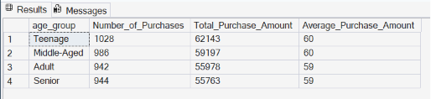

Total purchases by gender
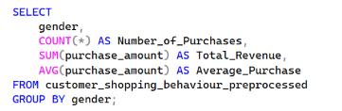
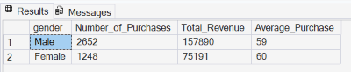

Most popular product categories
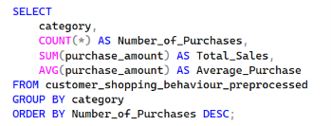
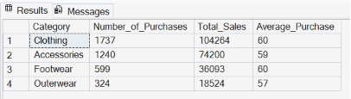

Purchasing during certain seasons
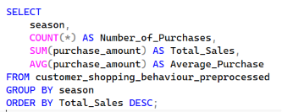
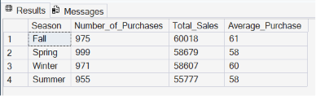

Discount effect on purchasing decisions
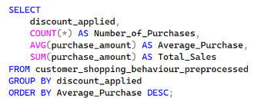
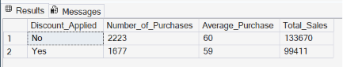

Ratings/Reviews effect on purchasing decisions
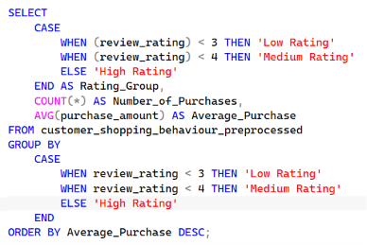
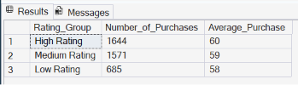

Most used payment methods
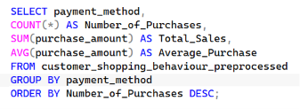
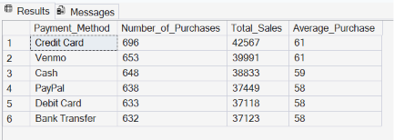

Frequency of purchases
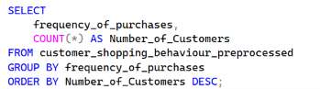
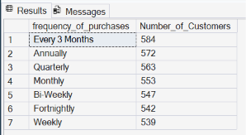

What makes customers come back and purchase again?

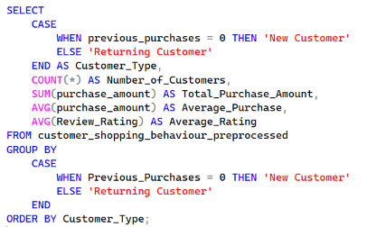
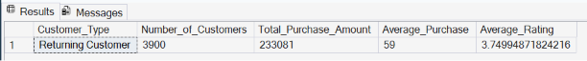

5. Dashboard in Power BI

